Foreign Key Constraint

🌟 Definition
# Source: AI Source: Provided by: [Data Path: Persons Table -> ID Column: 1, Name_En Column: Motasem Essam] -> From: [ChatGPT] on [6/10/2026]
A Foreign Key Constraint is a rule that creates and enforces a relationship between two tables.
A Foreign Key is a column (or set of columns) in one table that references the Primary Key of another table.

🎯 Purpose
# Source: AI Source: Provided by: [Data Path: Persons Table -> ID Column: 1, Name_En Column: Motasem Essam] -> From: [ChatGPT] on [6/10/2026]
The Foreign Key constraint is used to:
- Create relationships between tables
- Maintain referential integrity
- Prevent invalid references
- Ensure related records exist

🧠 Simple Example
# Source: AI Source: Provided by: [Data Path: Persons Table -> ID Column: 1, Name_En Column: Motasem Essam] -> From: [ChatGPT] on [6/10/2026]
Customers Table
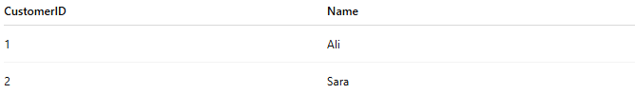
CustomerID | Name
1 | Ali
2 | Sara
Primary Key:
CustomerID

Orders Table
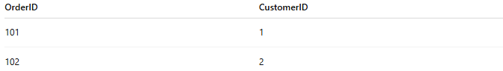
OrderID | CustomerID
101 | 1
102 | 2
Foreign Key:
CustomerID

Relationship:
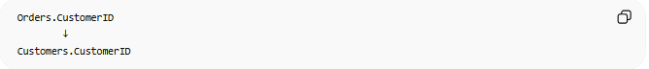
Orders.CustomerID
↓
Customers.CustomerID
The CustomerID in Orders must already exist in Customers.

🔢 How a Foreign Key Works
# Source: AI Source: Provided by: [Data Path: Persons Table -> ID Column: 1, Name_En Column: Motasem Essam] -> From: [ChatGPT] on [6/10/2026]
Valid Data
Customers
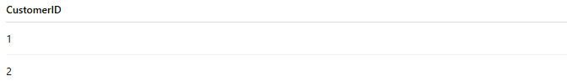
CustomerID
1
2
Orders
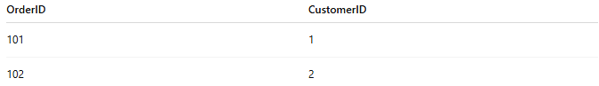
OrderID | CustomerID
101 | 1
102 | 2
All referenced customers exist.

Invalid Data
Orders
OrderID | CustomerID
103 | 99
CustomerID:
99
does not exist in Customers.
Result:
Error
The Foreign Key constraint rejects the insert.

📚 Real-World Examples
# Source: AI Source: Provided by: [Data Path: Persons Table -> ID Column: 1, Name_En Column: Motasem Essam] -> From: [ChatGPT] on [6/10/2026]
1. Customer → Orders
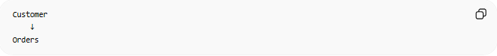
Customer
↓
Orders
Each order belongs to an existing customer.

2. Department → Employees
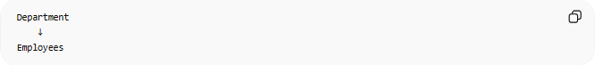
Department
↓
Employees
Each employee belongs to an existing department.

3. Category → Products
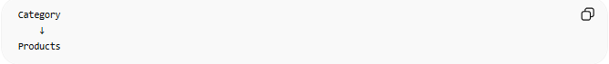
Category
↓
Products
Each product belongs to an existing category.

4. Teacher → Students

Teacher
↓
Students
Each student references an existing teacher.

📊 ER Diagram Representation
# Source: AI Source: Provided by: [Data Path: Persons Table -> ID Column: 1, Name_En Column: Motasem Essam] -> From: [ChatGPT] on [6/10/2026]
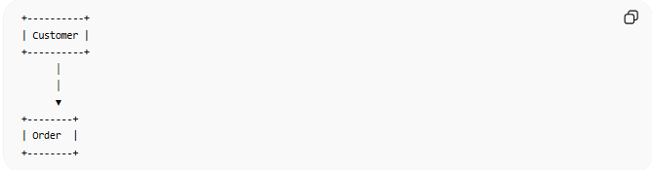
+----------+
| Customer |
+----------+
│
│
▼
+--------+
| Order |
+--------+
Relationship:
Customer 1 ───── N Orders

🗄️ SQL Example
# Source: AI Source: Provided by: [Data Path: Persons Table -> ID Column: 1, Name_En Column: Motasem Essam] -> From: [ChatGPT] on [6/10/2026]
Parent Table
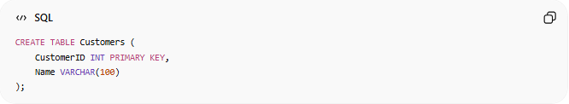
CREATE TABLE Customers (
CustomerID INT PRIMARY KEY,
Name VARCHAR(100)
);

Child Table
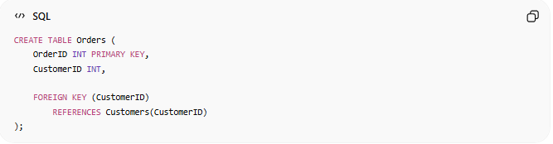
CREATE TABLE Orders (
OrderID INT PRIMARY KEY,
CustomerID INT,
FOREIGN KEY (CustomerID)
REFERENCES Customers(CustomerID)
);

Meaning
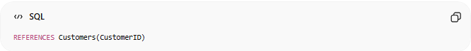
REFERENCES Customers(CustomerID)
means:
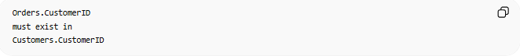
Orders.CustomerID
must exist in
Customers.CustomerID

🔢 Characteristics of a Foreign Key
# Source: AI Source: Provided by: [Data Path: Persons Table -> ID Column: 1, Name_En Column: Motasem Essam] -> From: [ChatGPT] on [6/10/2026]
A Foreign Key:
- References a Primary Key
- Creates table relationships
- Prevents orphan records
- Enforces referential integrity

🌍 E-Commerce Example
# Source: AI Source: Provided by: [Data Path: Persons Table -> ID Column: 1, Name_En Column: Motasem Essam] -> From: [ChatGPT] on [6/10/2026]
Customers
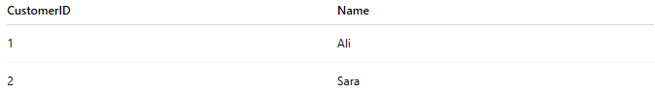
CustomerID | Name
1 | Ali
2 | Sara

Orders
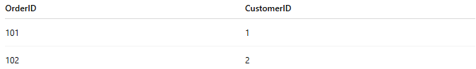
OrderID | CustomerID
101 | 1
102 | 2

Relationship:
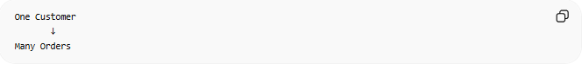
One Customer
↓
Many Orders
The Foreign Key enables this relationship.

🚫 Orphan Records
# Source: AI Source: Provided by: [Data Path: Persons Table -> ID Column: 1, Name_En Column: Motasem Essam] -> From: [ChatGPT] on [6/10/2026]
An orphan record is a child record without a valid parent.

Example
Orders:
OrderID | CustomerID
101 | 99
Customer 99 does not exist.
This creates an orphan record.
Foreign Keys prevent this situation.

🔄 Parent Table vs Child Table
# Source: AI Source: Provided by: [Data Path: Persons Table -> ID Column: 1, Name_En Column: Motasem Essam] -> From: [ChatGPT] on [6/10/2026]
Parent Table
Contains the Primary Key.
Example:
Customers
Primary Key:
CustomerID

Child Table
Contains the Foreign Key.
Example:
Orders
Foreign Key:
CustomerID

⚠️ Foreign Key vs Primary Key
# Source: AI Source: Provided by: [Data Path: Persons Table -> ID Column: 1, Name_En Column: Motasem Essam] -> From: [ChatGPT] on [6/10/2026]
Primary Key
Uniquely identifies a row.
Example:
CustomerID

Foreign Key
References a Primary Key in another table.
Example:
Orders.CustomerID

Comparison
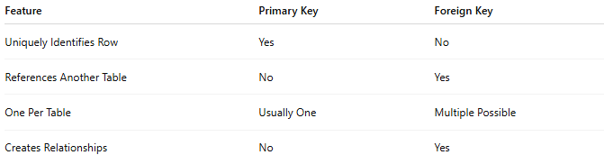
Feature | Primary Key | Foreign Key
Uniquely Identifies Row | Yes | No
References Another Table | No | Yes
One Per Table | Usually One | Multiple Possible
Creates Relationships | No | Yes

🔗 Foreign Key and Relationship Types
# Source: AI Source: Provided by: [Data Path: Persons Table -> ID Column: 1, Name_En Column: Motasem Essam] -> From: [ChatGPT] on [6/10/2026]
Foreign Keys are commonly used to implement:
One-to-One
Person ───── Passport

One-to-Many
Customer ───── Orders

Many-to-Many
Implemented through a junction table:
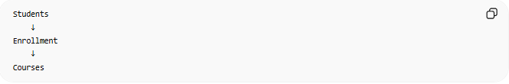
Students
↓
Enrollment
↓
Courses
The junction table contains two Foreign Keys.

📚 Common Foreign Key Examples
# Source: AI Source: Provided by: [Data Path: Persons Table -> ID Column: 1, Name_En Column: Motasem Essam] -> From: [ChatGPT] on [6/10/2026]
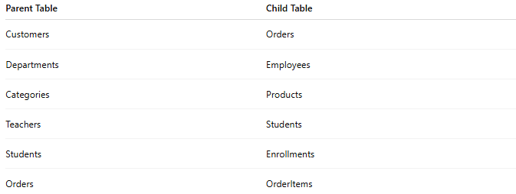
Parent Table | Child Table
Customers | Orders
Departments | Employees
Categories | Products
Teachers | Students
Students | Enrollments
Orders | OrderItems

🧠 Simple Analogy
# Source: AI Source: Provided by: [Data Path: Persons Table -> ID Column: 1, Name_En Column: Motasem Essam] -> From: [ChatGPT] on [6/10/2026]
Think of a university.
Every student must belong to an existing department.

Student → Computer Science
Student → Engineering
Student → Business
A student cannot belong to a department that does not exist.
The department reference acts like a Foreign Key.

🧭 Summary
# Source: AI Source: Provided by: [Data Path: Persons Table -> ID Column: 1, Name_En Column: Motasem Essam] -> From: [ChatGPT] on [6/10/2026]
A Foreign Key Constraint is a rule that links two tables by requiring a value in one table to match an existing Primary Key value in another table. It enforces referential integrity, prevents invalid references, and forms the foundation of relationships such as Customer–Orders, Department–Employees, and Category–Products.

